ToWe Project - Time Sheet

Project: | 2015-1-UK01-KA201-013431
Institution: | Kingston University
Period: | March – September 2018
Name of the employee | Yasmin Mukadam
Category of Staff | Researcher, Teacher/Trainer

Date | Activity – Intellectual Output | Hour
16.3.18 | IO3-presentions | 3.00
 | Total hours | IO3=3
7 ½ hours = 1 day | Total days | IO3=0.4

Date | 31.8.18 | Signature (employee) | 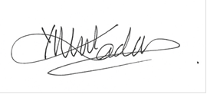
Date |  | Signature (employer) | 