ToWe Project - Time Sheet

Project: | 2015-1-UK01-KA201-013431
Institution: | Achieving for Children
Period: | September 2017 – February 2018
Name of the employee | Kathryn Hogarth
Category of Staff | Children’s Centre Manager and TOWE Practitioner

Date | Activity – Intellectual Output | IO | Hour
7.09.17 | Meeting with Ali | IO3, 4 and 5 | 2
28.09.17 | Meeting with Ali | IO3, 4 and 5 | 2
13.11.17 | Work in Centre – focus on children’s voice displays | IO4 | 2
15.11.17 | Meeting to Plan Conference | IO4 and 5 | 3
29.11.17 | Meet Tom to Plan Conference | IO4 and 5 | 2
12.12.17 | Visit Uni for Conference | IO5 | 2
28.12.17 | Conference Prep | IO5 | 5
01.01.18 | Conference Prep | IO5 | 6
04.01.18 | Conference Prep | IO5 | 2
07.01.18 | Conference Prep | IO5 | 4
10.01.18 | AfC/TOWE Conference | IO5 | 9
25.01.18 | Disseminating to Team | IO3, 4 and 5 | 1
02.02.18 | Preparing for setting visits – focus on children’s voice displays, snack café and languages | IO4, 5 and 6 | 6
 | Total hours |  | 46
7 ½ hours = 1 day | Total days |  | 6.13

Date | Feb 2018 | Signature (employee) | 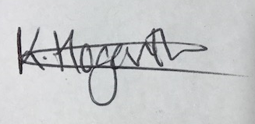
Date |  | Signature (employer)

