ToWe Project - Time Sheet

Project: | 2015-1-UK01-KA201-013431
Institution: | Achieving for Children
Period: | March 2017 – August 2017
 | Tom Maybey
Category of Staff | Lead Practitioner at North East Cluster (RUT) Children’s Centres

Date | Activity – Intellectual Output | Hour
Whole duration  March 20th – 24th  June 12th  July 10th  19th July | IO3 Discussing wellbeing all Stay and Play with parents and carers in attendance.  Sharing practice around IO3 through explanation of related setting provision with international partners  Adding ToWe wellbeing question to termly survey, plus explaining question to parents and carers  Meeting 10 July  Reflection notes on IO3 | 0.25 per session (approx) = total 11 hours  4 hours  1 hour  2 hours  3.5 hours  (IO3 total 21.5 hrs)
June 12th  June 20th | IO4 Reflection notes on children’s voice  Display creation | 4 hours  3.5 hours  (IO4 total 7.5 hrs)
Whole duration  July 21st | IO5 Spending time at snack café  Reflection notes on IO5 | 1 day  1 day  (IO5 total 2 days)
8th August | IO6 Making ‘child’s experience’ signs for visual timetable | 2 hours
3rd July | Survey creation  Collating and analyzing data from surveys, relating to ToWe and sending on statistics | 2.5 hours  3 hours  (total IO6 7.5 hrs)
7 ½ hours = 1 day | Total days | 51.5 hours

Date | 29 September 2017 | Signature (employee) | 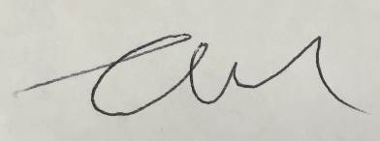
Date | 12.October,  2017 | Signature (employer) | 

