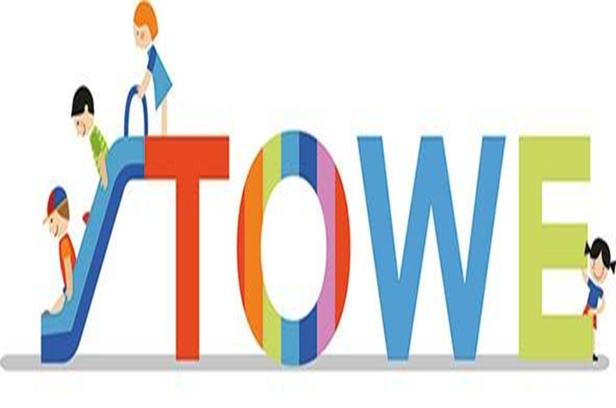

The ToWe Project

Enhancing Opportunities for Toddlers’ Wellbeing
Local Training Event Workshop
Date 10th January, 2018

Evaluation Form:

How good is the event?

The ToWe Project Partners will outline the project process and materials, describing how they have used the materials, strategies they have developed and their experience in supporting disadvantaged toddlers. They will be covering the following areas:
- Toddlers’ Wellbeing ,
- Toddlers’ Voice and Expressions,
- Toddlers’ Meal Times,
- Toddlers’ Additional Language(s)

No | Performance Indicator | Themes | 4 | 3 | 2 | 1
1 | Structure, content and delivery of the Local Workshop event | 4 = excellent, 3 = good, 2 - satisfactory and 1 = poor
1.1 | Organisation of the Local Workshop event | - Organisation of the event  - Information on the event  - Booking on website / email | 85% | 15%
1.2 | Effectiveness of content and appropriate range and balance of activities | - Appropriate content, clearly related to the aims and objectives of the event  - Relevant mixture of activities e.g. lectures, workshops and refreshment breaks | 90% | 10%
1.3 | Effectiveness of the delivery by trainers, workshop leaders etc. | - Presenters and leaders of workshops have the appropriate subject competence and knowledge  - Presenters and leaders of workshops are good communicators with the necessary language skills  - Presenters and leaders of workshops have the appropriate didactic experience for delivering professional development | 90% | 10%
1.4 | Effectiveness of shared ownership of the event | - Evidence that the needs and expectations of delegates have been taken into account  - Evidence that delegates have the opportunity to contribute their own expertise | 85% | 15%

No | Performance Indicator | Themes | 4 | 3 | 2 | 1
2 | Materials, resources and equipment | 4 = excellent, 3 = good, 2 satisfactory and 1 = poor
2.1 | Provision and suitability of materials, resources and equipment | - Evidence of appropriate prior information being issued to delegates  - Relevance and quality of materials issued during the event  - Sufficiency, range and suitability of other resources, including, where appropriate, ICT  - Extent to which technology and other resources are used effectively and within the event | 95% | 5%

No | Performance Indicator | Themes | 4 | 3 | 2 | 1
3 | Quality of the domestic arrangements | 4 = excellent, 3 = good, 2 satisfactory and 1 = poor
3.1 | Quality and appropriateness of the domestic arrangements and the comfort factor | - Attention to practical details and catering  - Suitability of the working venue  - Evidence of special requirements (dietary for example) being met | 90% | 10%

Any other comments:

- Very informative workshops – ‘not too long with enough information. Explained about ToWe well and showed the relevance and importance of the project’
- Sharing of tools, strategies & practical materials will enable us to embed this within the team. Thanks very much
- Very well organised workshops and the day flowed really well. I have taken away lots of ideas that I am keen to put in place at my setting. It has shown me the importance of ToW
- Everything during the Conference was well-organised and really helps us as early years practitioners
- Look forward to accessing more of the information provided / shared today on the AfC website

Thank you for taking part in this event.

